Regular Expressions

Question 1- Write a Python program to replace all occurrences of a space, comma, or dot with a colon.
Sample Text- 'Python Exercises, PHP exercises.'
Expected Output: Python:Exercises::PHP:exercises:
Answer : text = 'Python Exercises, PHP exercises.'
print(re.sub("[ ,.]", ":", text))

Question 2- Create a dataframe using the dictionary below and remove everything (commas (,), !, XXXX, ;, etc.) from the columns except words.
Dictionary- {'SUMMARY' : ['hello, world!', 'XXXXX test', '123four, five:; six...']}
Expected output-
0 hello world
1 test
2 four five six
Answer:
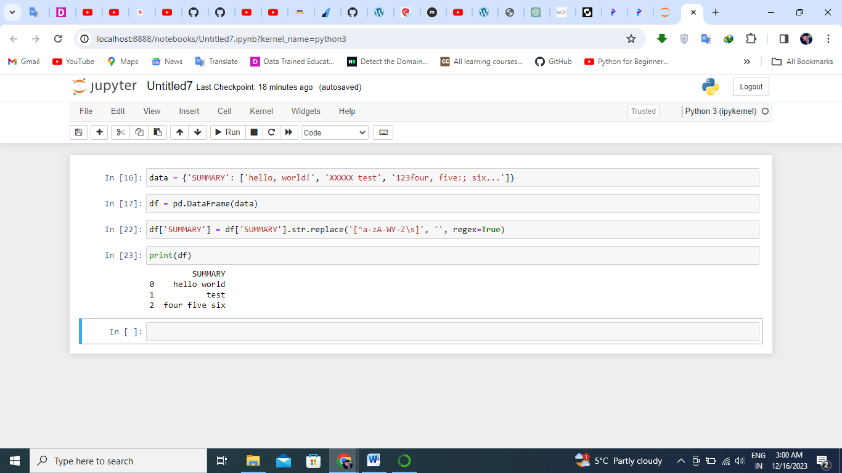

Question 3- Create a function in python to find all words that are at least 4 characters long in a string. The use of the re.compile() method is mandatory.
Answer: def find_long_words(input_str):
pattern = re.compile(fr'\b\w{{4,}}\b')
long_words = pattern.findall(input_str)
return long_words
input_text = "My name is Deepak Thakur , I have 3 pets Cat , Dog and a Parrot , These days iam working with FLIPROBO."
result = find_long_words(input_text)
print(result)
Question 4- Create a function in python to find all three, four, and five character words in a string. The use of the re.compile() method is mandatory.
Answer: def find_long_words(input_str):
pattern = re.compile(fr'\b\w{{3,5}}\b')
long_words = pattern.findall(input_str)
return long_words
input_text = "My name is Deepak Thakur , I have 3 pets Cat , Dog and a Parrot , These days iam working with FLIPROBO."
result = find_long_words(input_text)
print(result)
Question 5- Create a function in Python to remove the parenthesis in a list of strings. The use of the re.compile() method is mandatory.
Sample Text: ["example (.com)", "hr@fliprobo (.com)", "github (.com)", "Hello (Data Science World)", "Data (Scientist)"]
Expected Output:
example.com
hr@fliprobo.com
github.com
Hello Data Science World
Data Scientist
Answer :
def remove_parentheses(strings_list):
regex_pattern = re.compile(r'\([^)]*\)')
result_list = [regex_pattern.sub('', s).strip() for s in strings_list]
return result_list
text = ["example (.com)", "hr@fliprobo (.com)", "github (.com)", "Hello (Data Science World)", "Data (Scientist)"]
result = remove_parentheses(text)
Print("Strings without parentheses:")
print(item)
Question 6- Write a python program to remove the parenthesis area from the text stored in the text file using Regular Expression.
Sample Text: ["example (.com)", "hr@fliprobo (.com)", "github (.com)", "Hello (Data Science World)", "Data (Scientist)"]
Expected Output: ["example", "hr@fliprobo", "github", "Hello", "Data"]
Note- Store given sample text in the text file and then to remove the parenthesis area from the text.

Question 7- Write a regular expression in Python to split a string into uppercase letters.
Sample text: “ImportanceOfRegularExpressionsInPython”
Expected Output: [‘Importance’, ‘Of’, ‘Regular’, ‘Expression’, ‘In’, ‘Python’]
Answer : ef split_uppercase(text: str) -> list:
"""Splits a string into uppercase letters."""
result = re.findall(r'[A-Z][a-z]*', text)
return result
text = "ImportanceOfRegularExpressionsInPython"
output = split_uppercase(text)
print(output)
Question 8- Create a function in python to insert spaces between words starting with numbers.
Sample Text: “RegularExpression1IsAn2ImportantTopic3InPython"
Expected Output: RegularExpression 1IsAn 2ImportantTopic 3InPython
Answer : def insert_spaces(text: str) -> str:
"""Inserts spaces between words starting with numbers."""
modified_text = re.sub(r"(\d\w+)", r" \1", text)
return modified_text
text = "RegularExpression1IsAn2ImportantTopic3InPython"
print(insert_spaces(text))
Question 9- Create a function in python to insert spaces between words starting with capital letters or with numbers.
Sample Text: “RegularExpression1IsAn2ImportantTopic3InPython"
Expected Output: RegularExpression 1 IsAn 2 ImportantTopic 3 InPython

Question 10- Use the github link below to read the data and create a dataframe. After creating the dataframe extract the first 6 letters of each country and store in the dataframe under a new column called first_five_letters.
Github Link- https://raw.githubusercontent.com/dsrscientist/DSData/master/happiness_score_dataset.csv

Question 11- Write a Python program to match a string that contains only upper and lowercase letters, numbers, and underscores.
Answer :
def match_string(input_str):
pattern = re.compile(r'^[a-zA-Z0-9_]+$')
return bool(pattern.match(input_str))
print(match_string("Abc123_")) # Output: True
Question 12- Write a Python program where a string will start with a specific number.
Answer: def start_with_number(input_str, num):
pattern = re.compile(fr'^{num}')
return bool(pattern.match(input_str))
print(start_with_number("123abc", "123")) # Output: True
Question 13- Write a Python program to remove leading zeros from an IP address
Answer: def remove_leading_zeros(ip_address):
parts = [str(int(part)) for part in ip_address.split('.')]
return '.'.join(parts)
print(remove_leading_zeros("001.002.003.004")) # Output: "1.2.3.4"
Question 14- Write a regular expression in python to match a date string in the form of Month name followed by day number and year stored in a text file.
Sample text : ' On August 15th 1947 that India was declared independent from British colonialism, and the reins of control were handed over to the leaders of the Country’.
Expected Output- August 15th 1947
Note- Store given sample text in the text file and then extract the date string asked format.
Answer: import re

def extract_date_from_text(text):
pattern = re.compile(r'\b(?:January|February|March|April|May|June|July|August|September|October|November|December)\s+\d{1,2}(?:st|nd|rd|th)?\s+\d{4}\b')
match = pattern.search(text)
return match.group(0) if match else None

# Usage Example
sample_text = ' On August 15th 1947 that India was declared independent from British colonialism, and the reins of control were handed over to the leaders of the Country’.'
print(extract_date_from_text(sample_text)) # Output: "August 15th 1947"
Question 15- Write a Python program to search some literals strings in a string.
Sample text : 'The quick brown fox jumps over the lazy dog.'
Searched words : 'fox', 'dog', 'horse'
Answer: def search_literals(text, *words):
return [word for word in words if word in text]
sample_text = 'The quick brown fox jumps over the lazy dog.'
print(search_literals(sample_text, 'fox', 'dog', 'horse')) # Output: ['fox', 'dog']
Question 16- Write a Python program to search a literals string in a string and also find the location within the original string where the pattern occurs
Sample text : 'The quick brown fox jumps over the lazy dog.'
Searched words : 'fox'
Answer : def search_literal_location(text, word):
pattern = re.compile(fr'\b{word}\b')
match = pattern.search(text)
return match.start() if match else -1
sample_text = 'The quick brown fox jumps over the lazy dog.'
print(search_literal_location(sample_text, 'fox')) # Output: 16
Question 17- Write a Python program to find the substrings within a string.
Sample text : 'Python exercises, PHP exercises, C# exercises'
Pattern : 'exercises'.
Answer : def find_substrings(text, pattern):
return re.findall(pattern, text)
sample_text = 'Python exercises, PHP exercises, C# exercises'
pattern = 'exercises'
print(find_substrings(sample_text, pattern)) # Output: ['exercises', 'exercises', 'exercises']
Question 18- Write a Python program to find the occurrence and position of the substrings within a string.
Answer: def find_occurrence_position(text, substring):
positions = [(match.start(), match.end()) for match in re.finditer(substring, text)]
return len(positions), positions
print(find_occurrence_position("abababab", "ab")) # Output: (4, [(0, 1), (2, 3), (4, 5)])
Question 19- Write a Python program to convert a date of yyyy-mm-dd format to dd-mm-yyyy format.
Answer : import datetime
def convert_date_format(date_str):
date_obj = datetime.datetime.strptime(date_str, '%Y-%m-%d')
return date_obj.strftime('%d-%m-%Y')
print(convert_date_format("2023-12-16")) # Output: "16-12-2023"
Question 20- Create a function in python to find all decimal numbers with a precision of 1 or 2 in a string. The use of the re.compile() method is mandatory.
Sample Text: "01.12 0132.123 2.31875 145.8 3.01 27.25 0.25"
Expected Output: ['01.12', '145.8', '3.01', '27.25', '0.25']
Answer : def find_decimal_numbers(text):
pattern = re.compile(r'\b\d+\.\d{1,2}\b')
return pattern.findall(text)
sample_text = "01.12 0132.123 2.31875 145.8 3.01 27.25 0.25"
print(find_decimal_numbers(sample_text)) # Output: ['01.12', '145.8', '3.01', '27.25', '0.25']
Question 21- Write a Python program to separate and print the numbers and their position of a given string.
Answer: def separate_numbers_and_position(text):
return [(match.group(), match.start()) for match in re.finditer(r'\b\d+\b', text)]
print(separate_numbers_and_position("abc 123 def 456")) # Output: [('123', 4), ('456', 12)]
Question 22- Write a regular expression in python program to extract maximum/largest numeric value from a string.
Sample Text: 'My marks in each semester are: 947, 896, 926, 524, 734, 950, 642'
Expected Output: 950
Answer : def extract_max_numeric_value(text):
pattern = re.compile(r'\b\d+\b')
numbers = [int(match.group()) for match in pattern.finditer(text)]
return max(numbers)
sample_text = 'My marks in each semester are: 947, 896, 926, 524, 734, 950, 642'
print(extract_max_numeric_value(sample_text)) # Output: 950
Question 23- Create a function in python to insert spaces between words starting with capital letters.
Sample Text: “RegularExpressionIsAnImportantTopicInPython"
Expected Output: Regular Expression Is An Important Topic In Python
Answer: def insert_spaces_between_capital_letters(text):
return re.sub(r'([a-z])([A-Z])', r'\1 \2', text)
sample_text = "RegularExpressionIsAnImportantTopicInPython"
print(insert_spaces_between_capital_letters(sample_text)) # Output: "Regular Expression Is An Important Topic In Python"
Question 24- Python regex to find sequences of one upper case letter followed by lower case letters
Answer : def find_upper_lower_sequence(text):
return re.findall(r'[A-Z][a-z]*', text)
print(find_upper_lower_sequence("AbcDefGhi")) # Output: ['Abc', 'Def', 'Ghi']
Question 25- Write a Python program to remove continuous duplicate words from Sentence using Regular Expression.
Sample Text: "Hello hello world world"
Expected Output: Hello hello world

Question 26- Write a python program using RegEx to accept string ending with alphanumeric character.
Answer :
def ends_with_alphanumeric(input_str):
pattern = re.compile(r'.*\w$')
return bool(pattern.match(input_str))
sample_string = "abc123"
print(ends_with_alphanumeric(sample_string)) # Output: True
sample_string2 = "abc@"
print(ends_with_alphanumeric(sample_string2)) # Output: False
Question 27-Write a python program using RegEx to extract the hashtags.
Sample Text: """RT @kapil_kausik: #Doltiwal I mean #xyzabc is "hurt" by #Demonetization as the same has rendered USELESS <ed><U+00A0><U+00BD><ed><U+00B1><U+0089> "acquired funds" No wo"""
Expected Output: ['#Doltiwal', '#xyzabc', '#Demonetization']
Answer:

def extract_hashtags(text):
return re.findall(r'#\w+', text)
sample_text = """RT @kapil_kausik: #Doltiwal I mean #xyzabc is "hurt" by #Demonetization as the same has rendered USELESS <ed><U+00A0><U+00BD><ed><U+00B1><U+0089> "acquired funds" No wo"""
hashtags = extract_hashtags(sample_text)
print(hashtags)

Question 28- Write a python program using RegEx to remove <U+..> like symbols
Check the below sample text, there are strange symbols something of the sort <U+..> all over the place. You need to come up with a general Regex expression that will cover all such symbols.
Sample Text: "@Jags123456 Bharat band on 28??<ed><U+00A0><U+00BD><ed><U+00B8><U+0082>Those who are protesting #demonetization are all different party leaders"
Expected Output: @Jags123456 Bharat band on 28??<ed><ed>Those who are protesting #demonetization are all different party leaders

Question 29- Write a python program to extract dates from the text stored in the text file.
Sample Text: Ron was born on 12-09-1992 and he was admitted to school 15-12-1999.
Note- Store this sample text in the file and then extract dates.
Answer:
def extract_dates_from_file(file_path):
with open(file_path, 'r') as file:
text = file.read()
dates = re.findall(r'\b\d{2}-\d{2}-\d{4}\b', text)
return dates
sample_text = "Ron was born on 12-09-1992 and he was admitted to school 15-12-1999."
file_path = "sample_text.txt"
with open(file_path, 'w') as file:
file.write(sample_text)
extracted_dates = extract_dates_from_file(file_path)
print(extracted_dates)
Question 30- Create a function in python to remove all words from a string of length between 2 and 4.
The use of the re.compile() method is mandatory.
Sample Text: "The following example creates an ArrayList with a capacity of 50 elements. 4 elements are then added to the ArrayList and the ArrayList is trimmed accordingly."
Expected Output: following example creates ArrayList a capacity elements. 4 elements added ArrayList ArrayList trimmed accordingly.

Answer:

